**KRONOS**

**PUNCHING IN/OUT**

Employees are set up to either clock in/out at the Kronos clock or punch in/out on their computer by using time stamp.

* **Time Clock Instructions**
* Swipe your badge from top to bottom

Or

* Type your employee number using the keypad and press the arrow key at the bottom

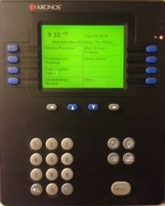

* The screen will have your name and say punch accepted.
* If the clock does not have your name the punch did not go through. Please let payroll know so that you can be added to Kronos.
* **Time Stamp**
* Log into Kronos Online

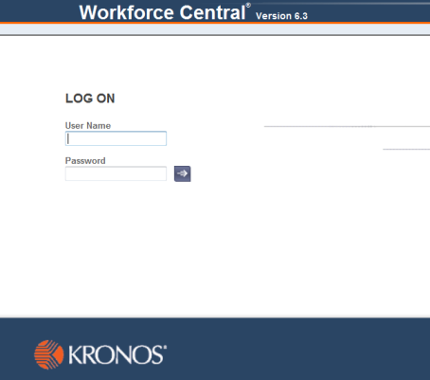<https://timekeeper.irvingisd.net/wfc/logon>

* User name = first initial, last name, employee ID #

(John Smith 15673 = jsmith15673)

Password = 12345678 (if it’s your first time)

If you need your password reset please contact payroll.

* Click on Record Time Stamp

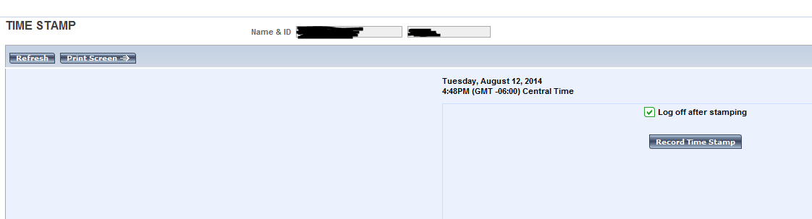

Kronos will automatically log you out.

**SCHEDULES**

Paraprofessionals should adhere to the schedule set by their supervisor. Kronos is set up with generic schedules, if the schedule on the time card does not match the paraprofessional’s actual work schedule; do not be concerned as long as the employee is working their required hours for the week. Working outside the generic schedule is reflected on the time card by a red box around the punch. All paraprofessionals are assigned a schedule according to the number of days they work per school year. The schedule established by the HR department. This shows the actual days you are scheduled to work. Any days worked outside of this schedule will result in earning comp, which needs to be approved by a supervisor prior to working. (For more information on comp time, please refer to the Paraprofessional Handbook-Policy DEA- Overtime Compensation.) The employee is to be on the clock for all work related activities.

**EARNING COMPENSATORY TIME**

When an employee works on a non-scheduled work day, that time will be recorded as compensatory time. It will be earned as comp-straight until 40 hours have been worked in the week. Any time after 40 hours will be earned at a rate of 1.5 (time and a half). Comp time will be updated accordingly in Kronos on a weekly basis. All comp time should be approved by the supervisor before earning. An employee can only accumulate up to 60 hrs (7.5days) of comp time. Anything over will be paid on a monthly basis. Any comp time not used by the end of the year will be paid.

**USE OF COMPENSATORY TIME**

A pay code is established in Kronos for when the employee wishes to use their comp time for an absence. If the employee wishes to be paid for any of their comp time during the year it must be approved by a supervisor and then the “Comp-Paid” code with total hours to be paid is added on the last day of the month.

**LUNCHES**

Meals are deducted automatically in Kronos based upon the lunch length established in the individual pay rule record. No lunch or a working lunch is recognized in Kronos also. If the length of a Paraprofessional lunch is changed or they do not take a lunch, payroll is to be notified immediately. All new campus employees will be set up as 30 minute lunch unless payroll is notified otherwise. All paraprofessionals should clock in/out for lunch unless otherwise approved by a supervisor. Leaving campus for personal appointments, whether taken in conjunction with lunch requires the employee to clock out when they depart and clock back in when they return. If taken during the normal lunch time (10:00 A.M. – 2:00 P.M.) Kronos will know to count part of the absence as lunch time.

Example:

1. Doris has a 30 minute lunch break she usually takes from 12:00 to 12:30. She leaves to go to the dentist at 11:30 A.M., she punches out and upon her return punches back in at 1:00 P.M. Kronos assumes her lunch was from 11:30a-1:00p. If she decides to take a lunch (let’s say) from 2:00p-2:30p, she will have to clock in/out for that as well.

If an employee is interrupted during a duty free lunch for a work related issue, their entire lunch needs to be cancelled. Employees violating this policy will be subject to disciplinary action which could lead to eventual termination.

If an employee works through their lunch the lunch deduction will need to be canceled. If it’s not canceled Kronos will automatically deduct 30 min from their day.

* **Cancel Lunches**
* Right click on in punch
* Edit punch
* Cancel Deductions
* Choose “All” (very bottom of the list)
* Click Ok
* Save time sheet

A red box will appear around the punch. To double check that the lunch was cancelled, hover over the punch, a box should pop up saying cancel deduction.

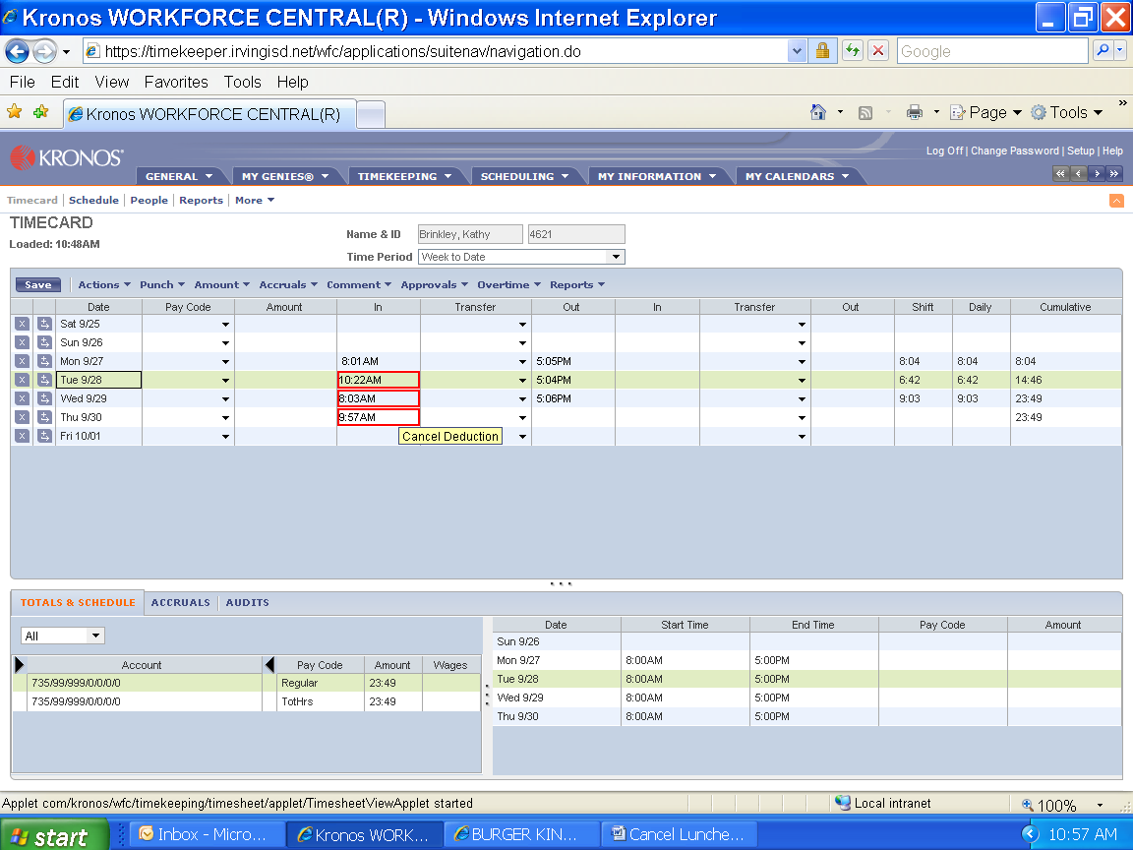

**SUMMER HOURS**

Employees that work during summer hours are required to punch out/in for lunch. No exceptions. A schedule for summer hours will be sent out by HR before those hours begin.

**BALANCING TIMESHEETS**

Timesheets are to be balanced every week. The weeks in Kronos run from Saturday to Friday. The previous week needs to be balanced by Tuesday at 5 the following week.

If an employee worked on Friday you balance the week to 39.5 hrs, if they were absent on Friday you balance their timesheet to 40 hrs. If we have short weeks then you would balance for the number of days (4 day week would be 31.5 or 32). In Kronos 39**:**30 is the same as 39**.**5.

When balancing the week do not look at the cumulative column at the top, look at the bottom of the timesheet under totals and schedule. A timesheet should never be balanced to over 40 hrs.

Email employees copying their supervisor to get any information needed to balance their timesheets (missing punches, absences, time short).

* **Missed Punches**
* Solid red box will show missed punch
* Click on red box
* Put in time (if the time is in the afternoon you must put the pm or in military time; example: missed punch at 4. Put in 4 pm or 1600 and Kronos will convert to 4 pm). If you put in 4 Kronos will assume that is 4am.
  + Military Time Conversion



* Any punch missed by an employee must have a comment.
* Right click on punch
* Add comment
* Choose comment that best explains why. You may also add a note to further explain if needed.
* Ok then save timesheet
* **Absences**
* An absence is shown by a red box around the day
* Click the arrow on the pay code box for the date of absence
* Scroll through the drop down list and choose the appropriate leave per employee
* Enter amount of time needed to balance the week
* Save timesheet
* **Time short for the week**
* If time is needed to balance the week add a line to the day short (always add the time to the day short, if they short more than one day spread the time out over all the days; don’t add it to one day)
* Click the button next to the day that has a + sign and an arrow
* On the line added click the arrow on the pay code box
* Scroll through the drop down list and choose the appropriate leave per employee
* Enter amount needed to balance the week
* Save timesheet

You can add the time by putting it in hours and minutes or you can use the decimal equivalent of the minutes; chart is below.

|  |  |  |  |  |  |  |  |  |  |  |
| --- | --- | --- | --- | --- | --- | --- | --- | --- | --- | --- |
| **Minute** |  | **Decimal** |  | **Minute** |  | **Decimal** |  | **Minute** |  | **Decimal** |
| :01 | = | 0.02 |  | :21 | = | 0.35 |  | :41 | = | 0.68 |
| :02 | = | 0.03 |  | :22 | = | 0.37 |  | :42 | = | 0.70 |
| :03 | = | 0.05 |  | :23 | = | 0.38 |  | :43 | = | 0.72 |
| :04 | = | 0.07 |  | :24 | = | 0.40 |  | :44 | = | 0.73 |
| :05 | = | 0.08 |  | :25 | = | 0.42 |  | :45 | = | 0.75 |
| :06 | = | 0.10 |  | :26 | = | 0.43 |  | :46 | = | 0.77 |
| :07 | = | 0.12 |  | :27 | = | 0.45 |  | :47 | = | 0.78 |
| :08 | = | 0.13 |  | :28 | = | 0.47 |  | :48 | = | 0.80 |
| :09 | = | 0.15 |  | :29 | = | 0.48 |  | :49 | = | 0.82 |
| :10 | = | 0.17 |  | :30 | = | 0.50 |  | :50 | = | 0.83 |
| :11 | = | 0.18 |  | :31 | = | 0.52 |  | :51 | = | 0.85 |
| :12 | = | 0.20 |  | :32 | = | 0.53 |  | :52 | = | 0.87 |
| :13 | = | 0.22 |  | :33 | = | 0.55 |  | :53 | = | 0.88 |
| :14 | = | 0.23 |  | :34 | = | 0.57 |  | :54 | = | 0.90 |
| :15 | = | 0.25 |  | :35 | = | 0.58 |  | :55 | = | 0.92 |
| :16 | = | 0.27 |  | :36 | = | 0.60 |  | :56 | = | 0.93 |
| :17 | = | 0.28 |  | :37 | = | 0.62 |  | :57 | = | 0.95 |
| :18 | = | 0.30 |  | :38 | = | 0.63 |  | :58 | = | 0.97 |
| :19 | = | 0.32 |  | :39 | = | 0.65 |  | :59 | = | 0.98 |
| :20 | = | 0.33 |  | :40 | = | 0.67 |  | :60 | = | 1.00 |

**EMPLOYEE ABSENCES**

Every absence for a paraprofessional will be accounted for in Kronos. Pay codes have been established in a drop down box in Kronos. Use of leave for IISD is taken in the following order: Local, State, Personal, EA. You can see the balance for the different types of leave in Kronos.

At the bottom of the timesheet click the accruals tab and all available leave for that employee will be visible.

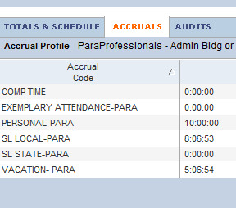

The time is listed as days, hrs, and min. Above the SL Local (Sick leave) is 8 days 6 hrs and 53 min.

The only absence codes that should be used for paraprofessionals are:

Personal illness, family illness, personal leave, death in immediate family, jury duty (always charge 8 hrs), comp time used, comp time paid, vacation, school business (always charge 8 hrs)

If any leave not listed above needs to be used please call the payroll department.

* **Reminders**
  + Only 3 personal leave days can be used in a row
  + Only 5 personal leave days can be used all year
  + A personal leave day cannot be used before or after a holiday without a Superintendent letter

**AFTERSCHOOL PROGRAMS**

All afterschool programs will be on Kronos. An employee must use the transfer key on the clock; there is no way to do a transfer on the computer.

* **Transfer Instructions**
* Clock out of your regular job
* Wait 1 minute then select the “After School Program” function key
* Use the “List” button (at bottom of screen) to see the program list
* Scroll down to the desired Program code (ex. 19208802 Journeys Program Para), then press the Enter key twice
* Enter your employee number and press enter
* You will see the punch transfer verification displayed-verify your name appeared and transfer has been accepted
* After work is complete, enter only your employee number and hit Enter (DO NOT USE TRANSFER KEY)
* **Balancing a timesheet with afterschool hours**

Don’t look at the cumulative column in Kronos look at the bottom under totals and schedules.

If the account has an (x) in front of it that time is for the afterschool program and should not be counted towards the total hours for the week.

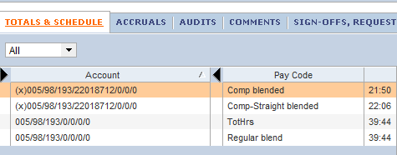

This person would be ok because their total hours are 39:44. If you were to look at the cumulative total at the top it would have 61:50 which is the 39:44 plus all of the hours from the afterschool program. If they don’t have enough total hours for the week (regardless of the afterschool program) time will need to be used to balance their week.

**END OF THE MONTH**

At the end of the month timesheets should be printed for all paraprofessionals at your campus.

* **Printing Timesheets**
  + From home screen where all your paras are listed go to actions select all
  + Make sure time period is the correct time frame you are wanting to print
  + Click on reports
  + Select time detail
  + Page break between employees should be YES
  + Click run report
  + Click refresh status until report is complete
  + Click on view report
  + Print

All timesheets need to be signed by the employee and their supervisor. This indicates they agree with the timesheet. Timesheets are kept on the campus.

* Secretaries must scan their signed timesheets and email to the Payroll Kronos Clerk

An employee has 60 days from the last day of the month to request changes to a month. No changes will be made after this 60 day period.