ENTERING BATCHES

- In MUNIS; Time and Attendance Entry – For Absences
  - Verify dates
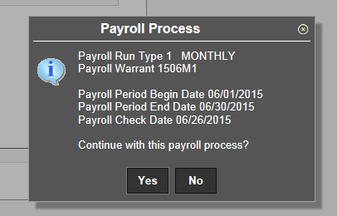
    - Yes
    - No if dates are wrong – contact the Payroll dept
  - Add Batch
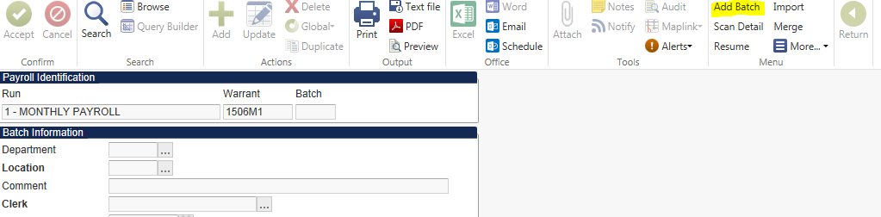
  - Department – Your Department
  - Location – Your Department
  - Comment – Identify what the batch is (ie, current month absences, Docks, etc)
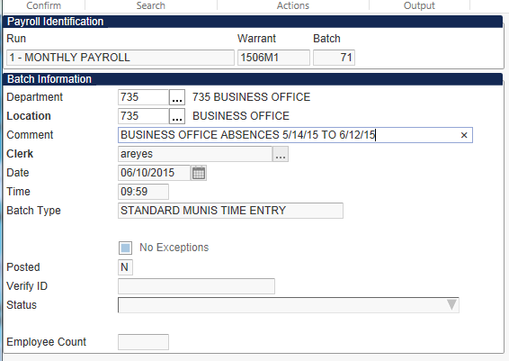
  - Enter
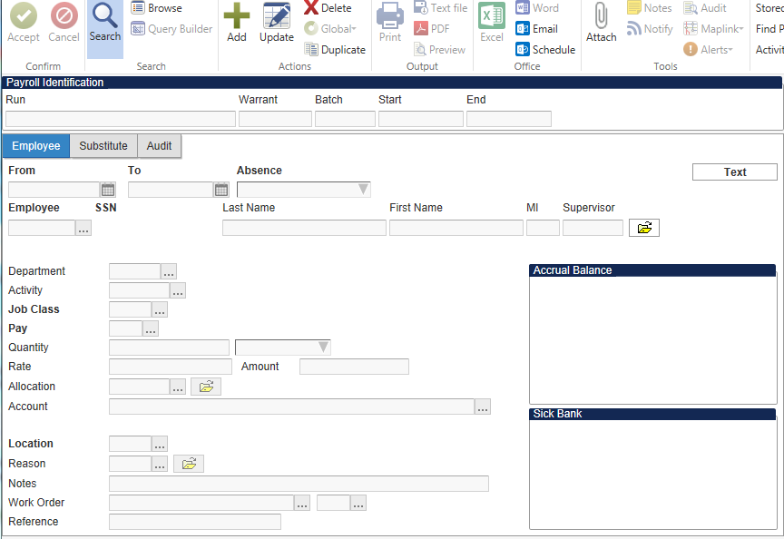
- Add (green plus sign)

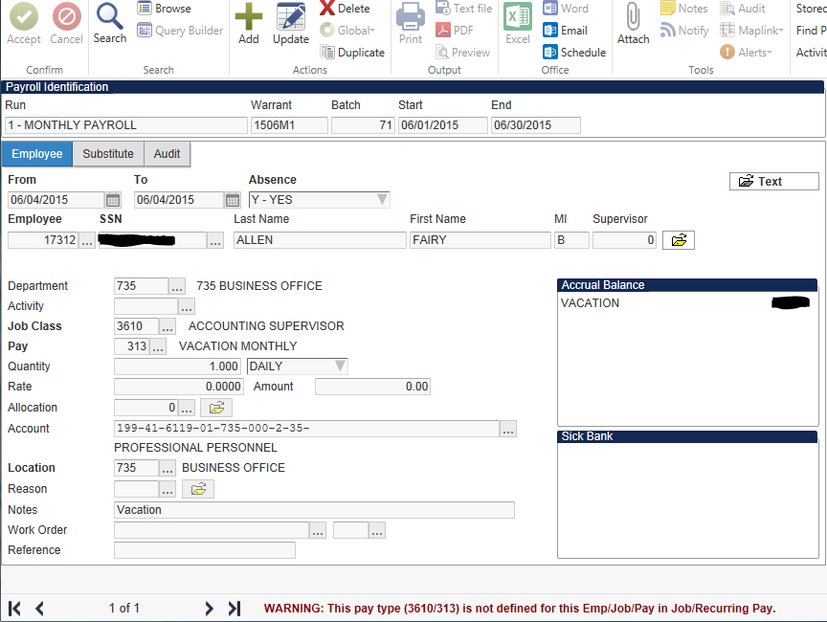
- From and To – Put in the single date of the occurrence or range of dates for same week (Monday – Friday)
- Absence – Yes
- Employee – ID
- Pay – See below for absence codes
Code | Description
190 | Sub VP/Principal 277
191 | Sub Counselor 195
301 | Personal Illness Monthly
302 | Family Illness Monthly
303 | Personal Leave Monthly
304 | Death Immediate Family Monthly
305 | Death Non-immediate Family Mo.
306 | Family Emergency Monthly
307 | Child Nurturing Monthly
308 | Workers Compensation Monthly
309 | Religious Holiday Monthly
310 | School Business Monthly
311 | Staff Development Monthly
312 | Staff Pullout Monthly
313 | Vacation Monthly
314 | Comp Time Used
315 | Jury Duty/Court Appear Monthly
316 | Military Leave Monthly
901 | Personal Dock - Full Rate Mo
902 | Personal Dock Prof Sub Rate
903 | Personal Dock Para Sub Rate

- Quantity
    - Enter the Quantity for the absence in days. MUNIS does not calculate the number of days (divide hours by 8)
  - 8 hours = 1.00
  - 7 hours = .88
  - 6 hours = .75
  - 5 hours = .63
  - 4 hours = .50
  - 3 hours = .38
  - 2 hours = .25
  - 1 hour = .13
      - Notes – what is absence for
      - Enter (If you get a Warning, entry will post, if you get Error, entry will not post)
      - Repeat until all absences have been added
      - Close by selecting the “Return” button on the top right side
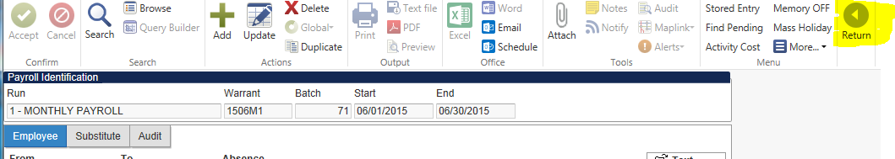

      - PDF
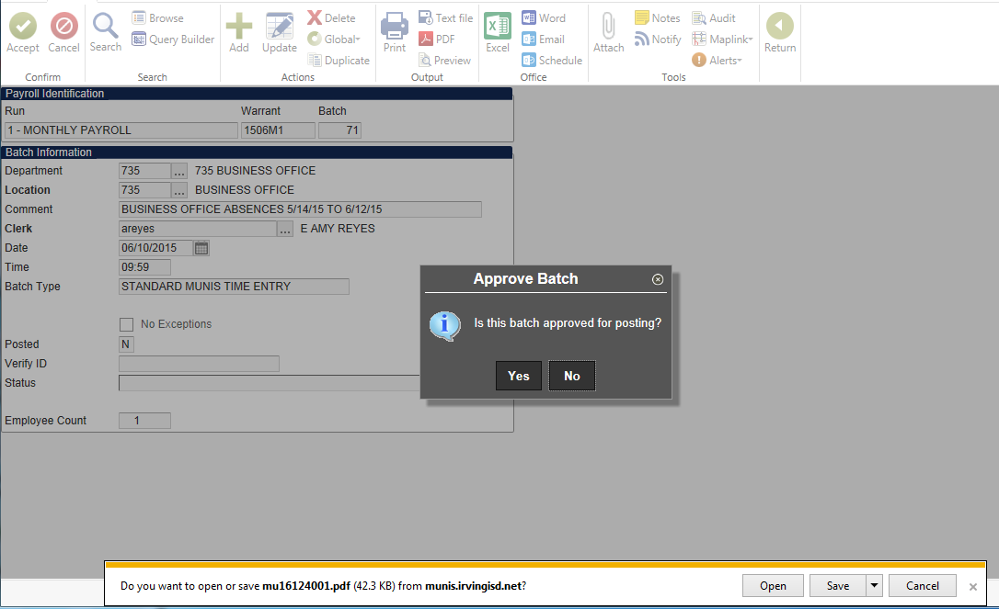
      - Yes to approve for posting
      - Open PDF to print or Save
      - Check that Verify ID shows your username

- In MUNIS; Time Entry – For Special Earnings
(Afterschool and Summer Programs should be on Kronos)
  - Verify dates
    - Yes
    - No if dates are wrong – contact the Payroll dept
  - Add Batch
  - Department – Your Department
  - Location – Your Department
  - Comment – Identify what the batch is (ie, English Tutoring, Math Tutoring, etc.)
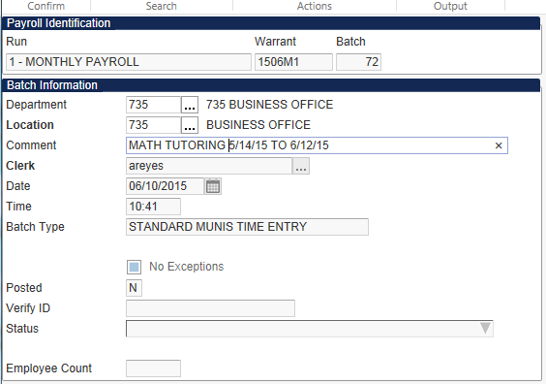
  - Enter
- Add (green plus sign)

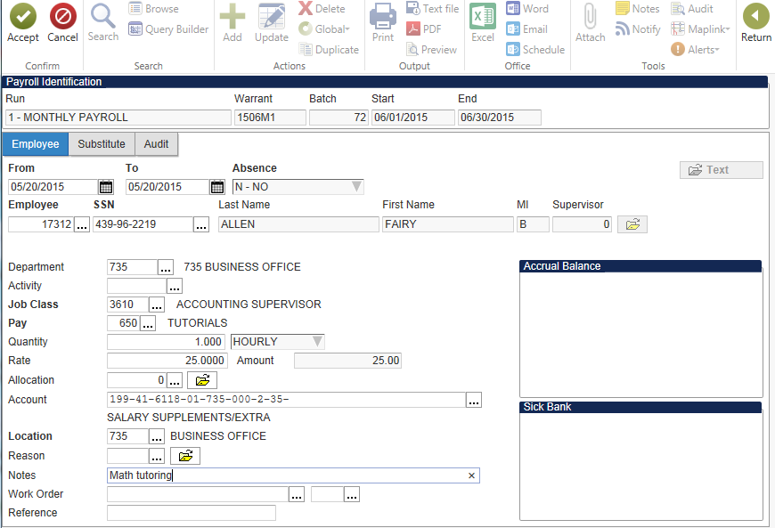
- From and To – add if specific date, otherwise leave date
- Absence – leave default of No
- Employee – ID
- Pay – See below for pay codes
Code | Description | Amount
615 | Staff Development Presentation | 25.00
620 | Staff Development Preparation | 25.00
624 | Job Coach | 13.00
625 | Facilitator For Major Stf Dev | 50.00
626 | Planning For Major Staf Dev Ev | 15.00
627 | Grant Biweekly | Hourly Rate
628 | Grant Paraprofessional | Hourly Rate
629 | Grant Professional | 25.00
630 | Required Training For Profe | 75.00
631 | Required Training For Others | 30.00
645 | Extended Instruction Teacher | 35.00
646 | Extended Instruction Aide | 15.00
647 | Extended Instr. Summer Session | 500.00
648 | Extended Instr. Secretary | 12.50
650 | Tutorials | 25.00
651 | Tutorials Para/Non Certified | 15.00
660 | Detention Hall Duty | 15.00
661 | Saturday School | 15.00
665 | Credit By Exam Or Test Proctor | 20.00
670 | Sign Language Interpreter | 35.00
671 | Other Language Oral Interpret | 15.00
672 | Other Language Written Intpet | 25.00
675 | Parent Facilitator | 17.00
- Quantity – number of hours/days/amount (HOURLY, DAILY, AMOUNT)
- Verify rate and Amount (Very important)
- Account – use correct account coding for special earnings
- Notes – describe the event/reason
- Repeat until all additional pay has been added
- Close by selecting the “Return” button on the top right side
- PDF – Review report before approving batch
- Yes to approve for posting-then your ID shows up in verify ID

- In MUNIS; Time Entry – Resuming existing batches
  - Verify dates
    - Yes
    - No if dates are wrong – contact the Payroll dept
  - Search – enter your Batch number
  - Enter
  - Resume
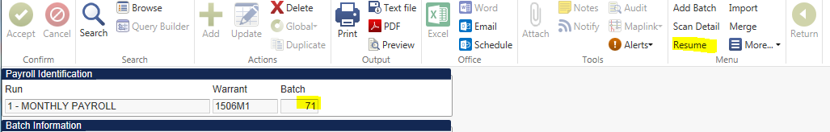
  - Enter additional absences/pay
  - Close
  - PDF – review report before approving batch
  - Yes to approve for posting-then your ID shows up in verify ID

